Seal Skull Measurements

Louise Barwell, Matthew Hodgkinson, Julija Kanto, Kamini Manick, Muriel Rabone

19/05/2017

## Introduction

Task: Seal Skull Measurements

Curator: Dr Richard Sabin, Collections Manager-Vertebrates, LS Division

This repository contains data and scripts for the analysis of skull measurements from a collection of seal skulls in the Natural History Museum, London. The raw data contain measurements of condylobasal length, zygomatic width and palatal length for 23 individuals of the species Halichoerus grypus (grey seal) collected in the British Isles. Twenty-three of the specimens were presented to the museum by Dr. H. R. Hewer (General Letter 1961/28) and two were presented by Dr. R. M. Laws. The seal skulls which were from various places in Scotland. Some of the seals had been culled.

## [1] "2017-05-15_Photos_H.grypus"   
## [2] "2017-05-15_Seal_Skull_Measurements-written.JPG"  
## [3] "2017-05-15_Seal_Skull_raw.csv"   
## [4] "2017-05-15_Seal_Skull_raw.xlsx"   
## [5] "2017-05-18_rmarkdowndraft_matt.Rmd"   
## [6] "2017-05-18_Seal_Skulls.Rproj"   
## [7] "2017-05-18_Summary_Text.docx"   
## [8] "2017-05-18_Summary_Text.Rmd"   
## [9] "Archive"   
## [10] "CBL VS ZW.png"   
## [11] "clean_seal_skulls.R"   
## [12] "H.grypus Poland.jpg"   
## [13] "IMG_3698.JPG"   
## [14] "map_draft.rmd"   
## [15] "ReadMe_SealSkulls"   
## [16] "ReadMe_SealSkulls_project.Rmd"   
## [17] "seal_clean.csv"   
## [18] "seal_skulls_clean.csv"   
## [19] "seal_skulls_draft_plots.rmd"   
## [20] "seal_skulls_metadata_shell.csv"   
## [21] "seal_skulls_metadata.csv"   
## [22] "seal_skulls.Rmd"   
## [23] "test_KM.Rmd"

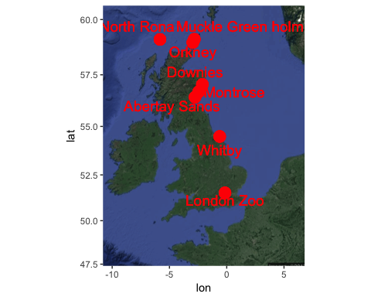 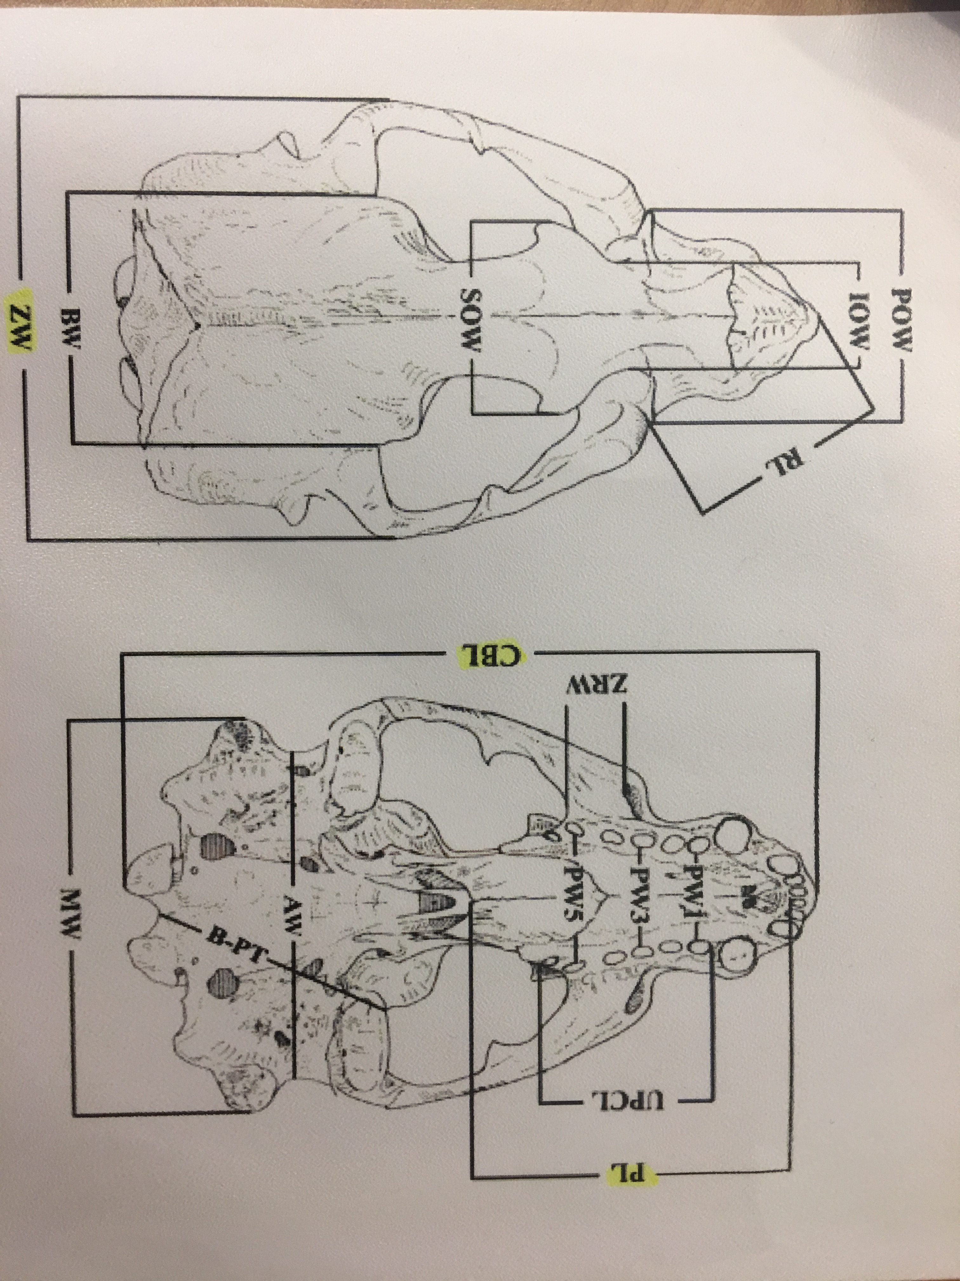

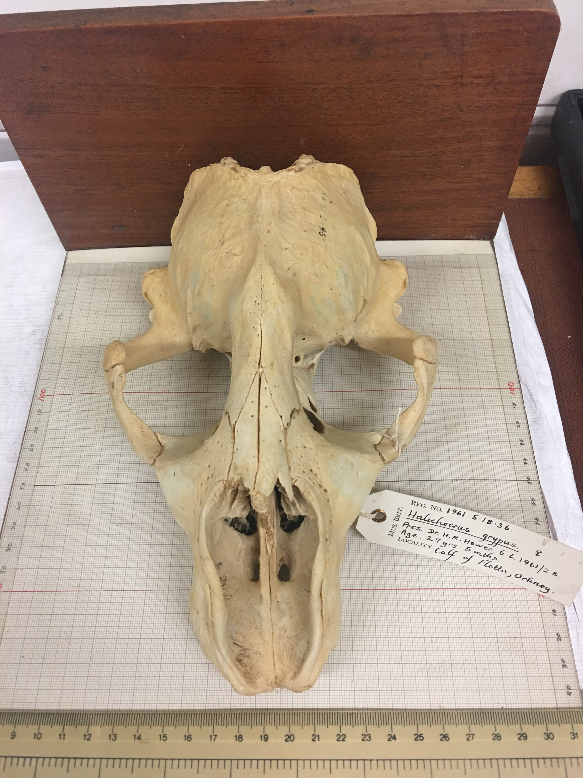

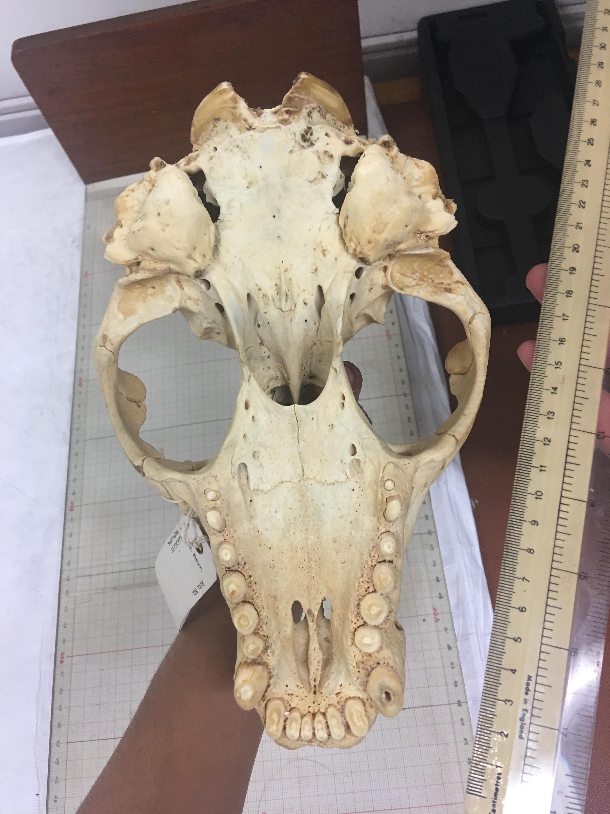

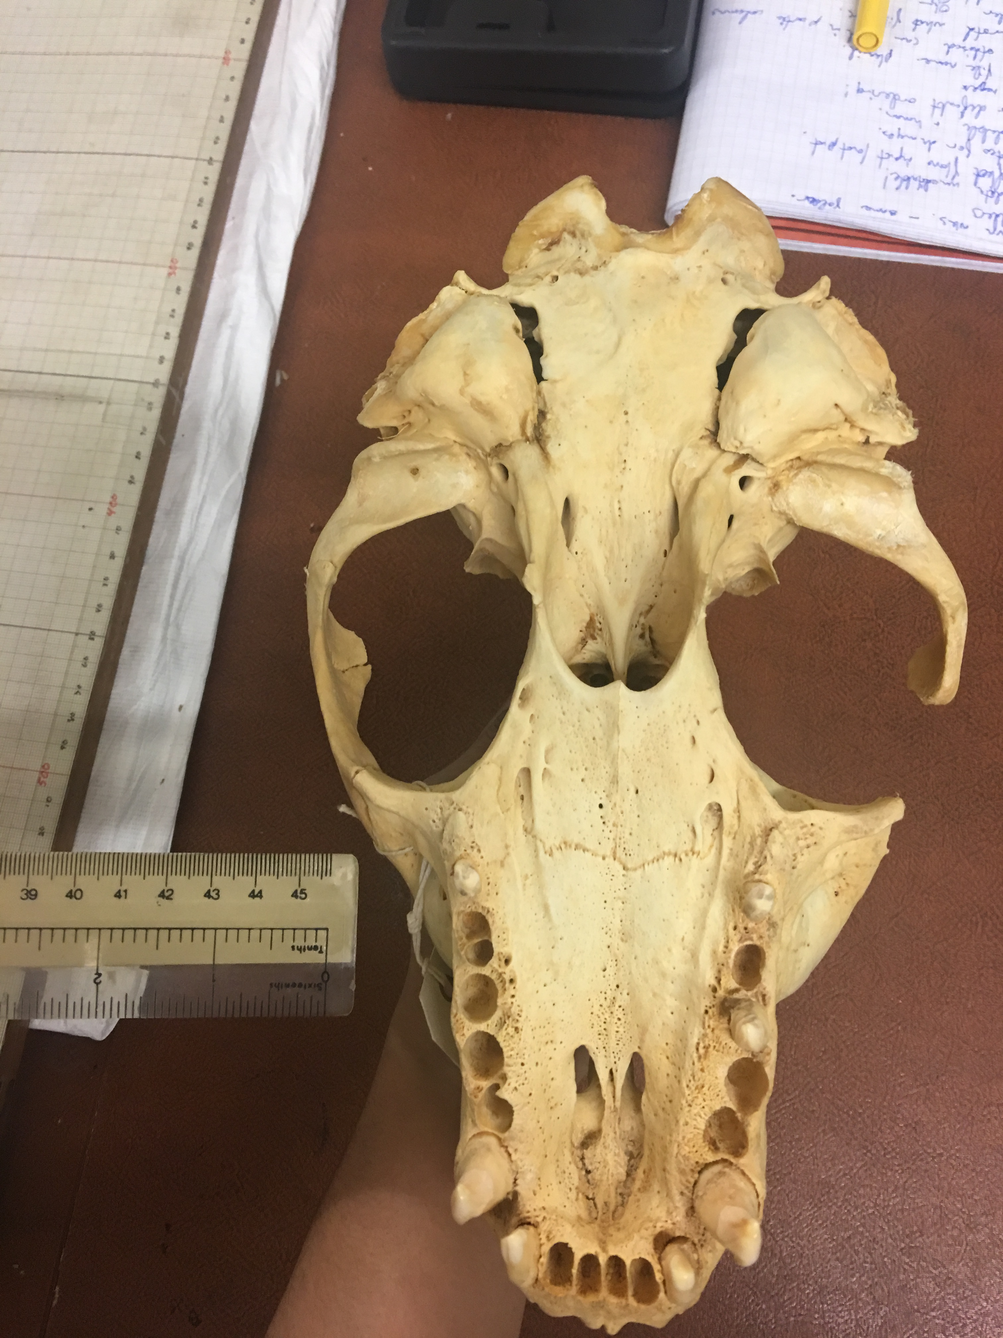 From looking at the tags attached to each specimen, we agreed to collect the following raw data and took it in turns to measure the skulls as selected by Richard:

## # A tibble: 23 × 9  
## X1 Registration_Number Age Sex Locality  
## <int> <chr> <int> <chr> <chr>  
## 1 1 1961.5.18.16 156 Male Little Greenholm, Orkney  
## 2 2 1961.5.18.12 122 Male Muckle, Greenholm, Orkney  
## 3 3 1961.5.18.01 1 Male Downies, Kincardinshire  
## 4 4 1961.5.18.17 204 Male North Rona  
## 5 5 1961.5.18.19 10 Female Abertay Sands  
## 6 6 1961.1.23.2 NA Female Fianuis central, North Roma  
## 7 7 1961.5.18.11 101 Male Barrel of Butter, Orkney  
## 8 8 1961.1.23.4 NA Female Fianuis central, North Roma  
## 9 9 1961.5.18.22 55 Female Abertay Sands  
## 10 10 1961.5.18.23 72 Female London Zoo (ex. Farne Islands)  
## # ... with 13 more rows, and 4 more variables: CBL <int>, ZW <dbl>,  
## # PL <dbl>, Comments <chr>

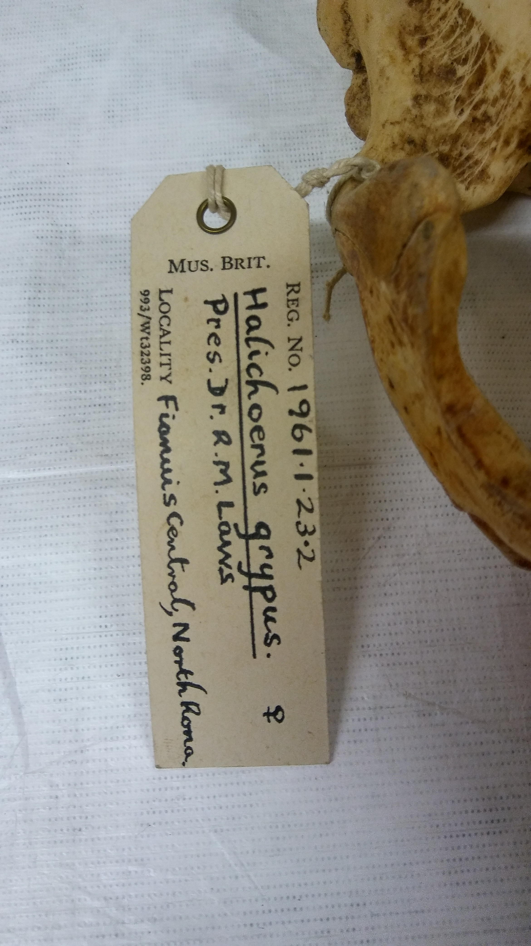

As a back up, we wrote down each measurement:

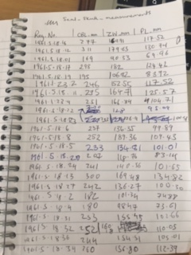

## Data Processing: Clean Data

The file clean_seal_skulls.R in the git repository takes the raw data and outputs a clean version (the file seal_skulls_clean.csv), which is used in all analyses.

## # A tibble: 6 × 9  
## X1 Registration_Number Age Sex Locality CBL  
## <int> <chr> <int> <chr> <chr> <int>  
## 1 1 1961.5.18.16 156 Male Little Greenholm, Orkney 277  
## 2 2 1961.5.18.12 122 Male Muckle, Greenholm, Orkney 311  
## 3 3 1961.5.18.01 1 Male Downies, Kincardinshire 169  
## 4 4 1961.5.18.17 204 Male North Rona 298  
## 5 5 1961.5.18.19 10 Female Abertay Sands 195  
## 6 6 1961.1.23.2 NA Female Fianuis central, North Roma 246  
## # ... with 3 more variables: ZW <dbl>, PL <dbl>, Comments <chr>

## Data Processing: Metadata

## # A tibble: 6 × 12  
## attributeName attributeDefinition  
## <chr> <chr>  
## 1 Registration_Number Unique identifier within the seal skulls collection  
## 2 Age Age of seal known from tagging  
## 3 Sex Sex of seal  
## 4 Locality Location of collection  
## 5 CBL Condylobasal length  
## 6 ZW Zygomatic width  
## # ... with 10 more variables: columnClasses <chr>, numberType <chr>,  
## # unit <chr>, instrument <chr>, minimum <dbl>, maximum <dbl>,  
## # formatString <chr>, definition <chr>, code <chr>, levels <chr>

## Data Analysis

## Registration_Number age_months Sex CBL ZW PL  
## 1 1961.5.18.16 156 Male 277 169.91 117.52  
## 2 1961.5.18.12 122 Male 311 179.65 130.74  
## 3 1961.5.18.01 1 Male 169 90.33 69.96  
## 4 1961.5.18.17 204 Male 298 182.00 124.42  
## 5 1961.5.18.19 10 Female 195 106.82 83.92  
## 6 1961.5.18.11 101 Male 295 164.71 125.57

## [1] "Registration_Number" "age_months" "Sex"   
## [4] "CBL" "ZW" "PL"

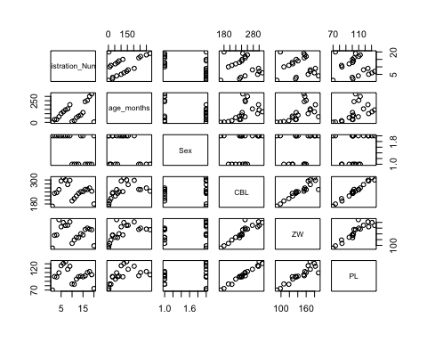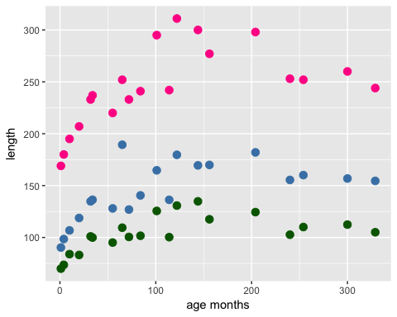

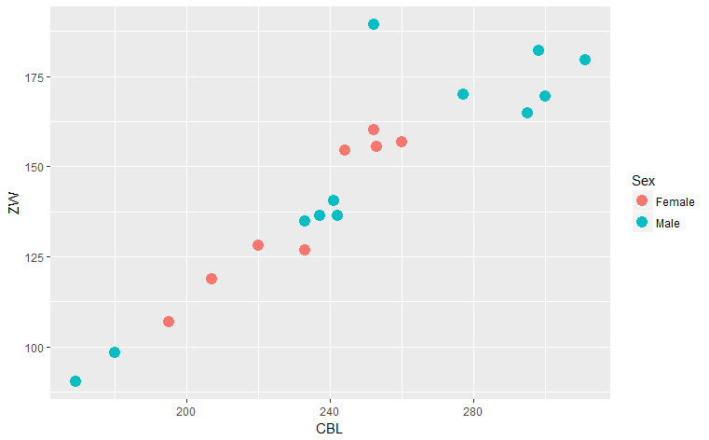

MEAN and RANGE - AGE - Female

## [1] 160

## [1] 10 329

MEAN and RANGE - AGE - Male

## [1] 88.41667

## [1] 1 204

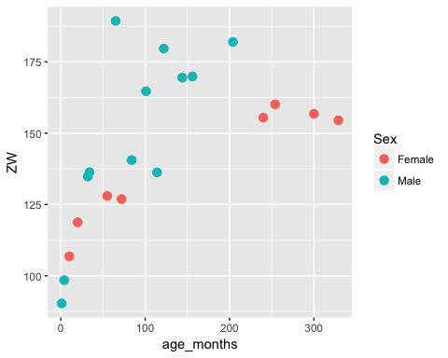

## [1] 138.4175

## [1] 149.325

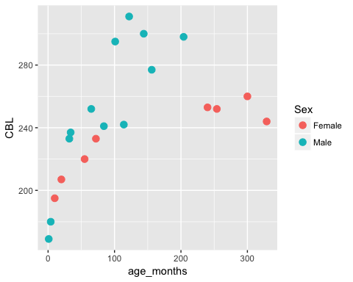

## [1] 233

## [1] 252.9167

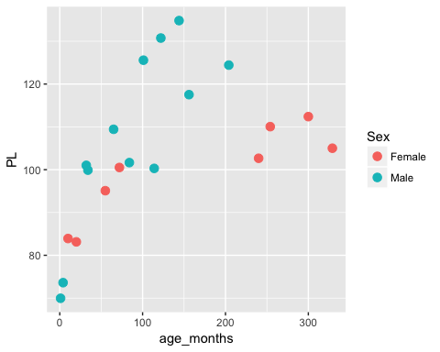

## [1] 99.09625

## [1] 107.41

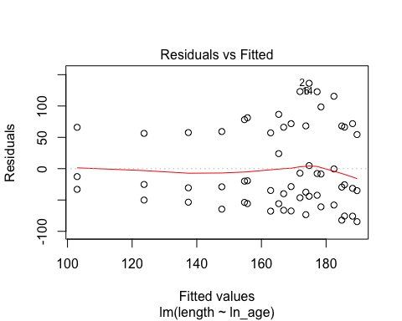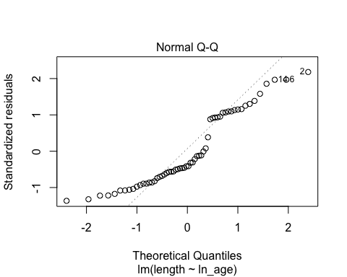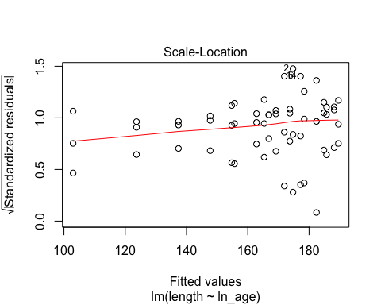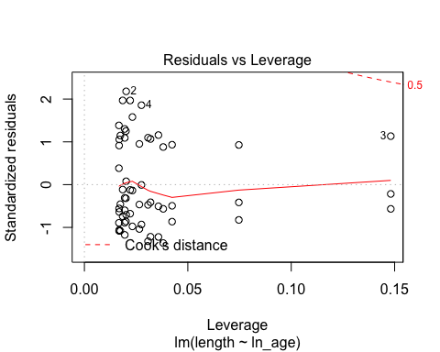

## Analysis of Variance Table  
##   
## Response: length  
## Df Sum Sq Mean Sq F value Pr(>F)   
## ln_age 1 28942 28942 7.2662 0.009179 **  
## Residuals 58 231015 3983   
## ---  
## Signif. codes: 0 '***' 0.001 '**' 0.01 '*' 0.05 '.' 0.1 ' ' 1

##   
## Call:  
## lm(formula = length ~ ln_age, data = test1)  
##   
## Residuals:  
## Min 1Q Median 3Q Max   
## -84.56 -50.93 -25.41 60.95 136.25   
##   
## Coefficients:  
## Estimate Std. Error t value Pr(>|t|)   
## (Intercept) 102.982 24.290 4.240 8.14e-05 ***  
## ln_age 14.940 5.542 2.696 0.00918 **   
## ---  
## Signif. codes: 0 '***' 0.001 '**' 0.01 '*' 0.05 '.' 0.1 ' ' 1  
##   
## Residual standard error: 63.11 on 58 degrees of freedom  
## Multiple R-squared: 0.1113, Adjusted R-squared: 0.09601   
## F-statistic: 7.266 on 1 and 58 DF, p-value: 0.009179

## age_months  
## 1 0.2500000  
## 2 0.3080808  
## 3 0.3661616  
## 4 0.4242424  
## 5 0.4823232  
## 6 0.5404040

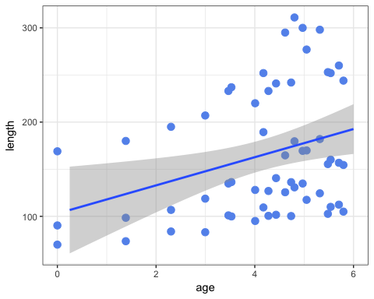

## CBL Only

## age_months  
## 1 0.2500000  
## 2 0.3080808  
## 3 0.3661616  
## 4 0.4242424  
## 5 0.4823232  
## 6 0.5404040

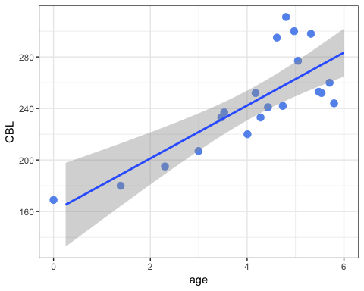

## ZW Only

## age_months  
## 1 0.2500000  
## 2 0.3080808  
## 3 0.3661616  
## 4 0.4242424  
## 5 0.4823232  
## 6 0.5404040

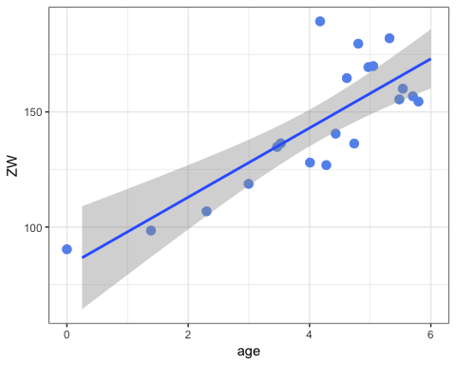

## PL Only

## age_months  
## 1 0.2500000  
## 2 0.3080808  
## 3 0.3661616  
## 4 0.4242424  
## 5 0.4823232  
## 6 0.5404040

